# IT Workshop

**[2ES111]**

**Computer Engineering & Information Technology**

**Semester- 2**



**U V Patel College of Engineering**

Question 1:

Code:

<html>

    <head>

        <script src=https://ajax.googleapis.com/ajax/libs/angularjs/1.7.9/angular.js></script>

    </head>

    <body >

        <div>

            plain text : {{10 + 20}}

        </div>

        <div ng-app="">

            Expression : {{10+20}}

        </div>

    </body>

</html>

Output:

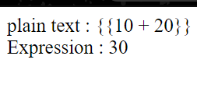

Question 2:

Code:

<html >

    <head>

        <script src=https://ajax.googleapis.com/ajax/libs/angularjs/1.7.9/angular.js></script>

    </head>

    <body>

        <h1> Sample Application</h1>

        <div ng-app="">

            <p> Enter your name: <input type="text" ng-model="name"></p>

            <p> Hello <h3 ng-bind="name"></h3>

            </p>

        </div>

    </body>

</html>

Output:

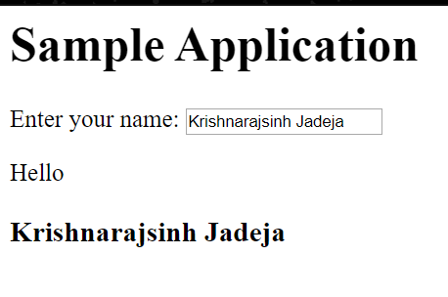

Question 3:

Code:

<html>

    <head>

        <script src=https://ajax.googleapis.com/ajax/libs/angularjs/1.7.9/angular.js></script>

    </head>

    <body>

        <h1>Sample Application</h1>

        <div ng-app="">

            <table border="0">

                <tr>

                    <td><input type="checkbox" ng-model="enableDisableButton">Disable Button</td>

                    <td><button ng-disabled="enableDisableButton">Click Me!!</button></td>

                </tr>

                <tr>

                    <td><input type="checkbox" ng-model="showHide">Show Button</td>

                    <td><button ng-show="showHide">Click Me!!</button></td>

                    <td><input type="text" ng-show="showHide"></td>

                </tr>

                <tr>

                    <td>Total click: {{c}}</td>

                    <td><button ng-click="c=c + 1"> Click Me!</button></td>

                </tr>

            </table>

        </div>

    </body>

</html>

Output:

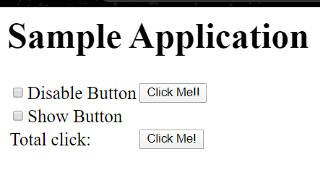

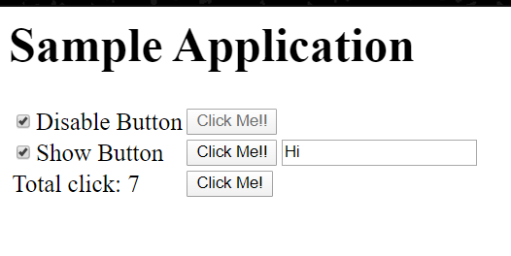

Question 4:

Code:

<html>

    <head>

        <title>AngularJS Expression</title>

        <script src=https://ajax.googleapis.com/ajax/libs/angularjs/1.7.9/angular.js></script>

    </head>

    <body>

        <form id="form1">

            <div ng-app="">

                <table>

                    <tr>

                        <td>First Name</td>

                        <td>

                            <input type="text" ng-model="FirstName"/>

                        </td>

                    </tr>

                    <tr>

                        <td>Last Name</td>

                        <td>

                            <input type="text" ng-model="LastName"/>

                        </td>

                    </tr>

                    <tr>

                        <td>Quantity</td>

                        <td>

                            <input type="text" ng-model="Quantity"/>

                        </td>

                    </tr>

                    <tr>

                        <td>Cost</td>

                        <td>

                            <input type="text" ng-model="Cost"/>

                        </td>

                    </tr>

                    <tr>

                        <td>

                            <input type="button" value="Click Me" ng-click="message = FirstName + ' ' + LastName + ' has to pay' + Cost * Quantity"/>

                        </td>

                        <td>

                            {{message}}

                        </td>

                    </tr>

                </table>

            </div>

        </form>

    </body>

</html>

Output:

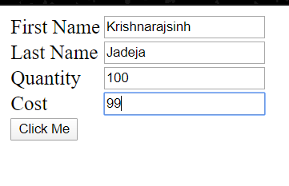

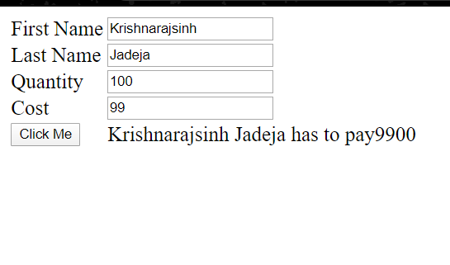

Question 5:

Code:

<html>

    <head>

        <script src=https://ajax.googleapis.com/ajax/libs/angularjs/1.7.9/angular.js></script>

        <script src="AJ-5.js"></script>

    </head>

    <body ng-app="myModule">

        <div ng-controller="firstController">

            {{message}}

        </div>

    </body>

</html>

var app = angular.module("myModule",[]);

app.controller("firstController",function($scope) {

    $scope.message = " Angular JS Turorial";

});

Output:

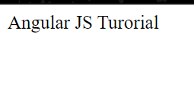

Question 6:

Code:

<html>

    <head>

        <script src=https://ajax.googleapis.com/ajax/libs/angularjs/1.7.9/angular.js></script>

        <script src="AJ-6.js"></script>

    </head>

    <body ng-app="myModule">

        <div ng-controller="dataController">

            <table>

                    <th>First Name</th>

                    <th>Last Name</th>

                    <th>Gender</th>

                    <th>Salary</th>

                <tr ng-repeat="emp in employeeList">

                    <td> {{emp.firstName}}</td>

                    <td>{{emp.lastName}}</td>

                    <td>{{emp.gender}}</td>

                    <td>{{emp.salary}}</td>

                </tr>

            </table>

        </div>

    </body>

</html>

var app = angular.module("myModule",[]);

app.controller("dataController",function($scope){

    var employees = [

        {firstName:"JACK",lastName:"SPARROW",gender:"Male",salary:2000000},

        {firstName:"ALICE",lastName:"JACK",gender:"Female",salary:34000},

        {firstName:"JONNY",lastName:"DRAW",gender:"Male",salary:23000},

        {firstName:"TIA",lastName:"Khanna",gender:"Female",salary:50000}

    ];

    $scope.employeeList = employees;

});

Output:

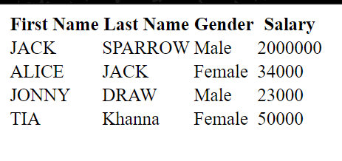

Question 7:

Code:

<html>

    <head>

        <script src=https://ajax.googleapis.com/ajax/libs/angularjs/1.7.9/angular.js></script>

        <script src="AJ-6.js"></script>

    </head>

    <body ng-app="myModule">

        <div ng-controller="dataController">

            <input type="text" ng-model="search.firstName"/>

            <input type="text" ng-model="search.lastName"/>

            <table>

                    <th>First Name</th>

                    <th>Last Name</th>

                    <th>Gender</th>

                    <th>Salary</th>

                </tr>

                <tr ng-repeat="emp in employeeList | filter: search| orderBy: '-salary'">

                    <td> {{emp.firstName | lowercase}}</td>

                    <td>{{emp.lastName | uppercase}}</td>

                    <td>{{emp.gender}}</td>

                    <td>{{emp.salary |  currency:"@"}}</td>

                </tr>

            </table>

        </div>

    </body>

</html>

Output:

